## **Purvi - World Challenge SQL**

## **Using COUNT, get the number of cities in the USA.**

SELECT COUNT(CountryCode)

FROM city

WHERE CountryCode = 'USA';

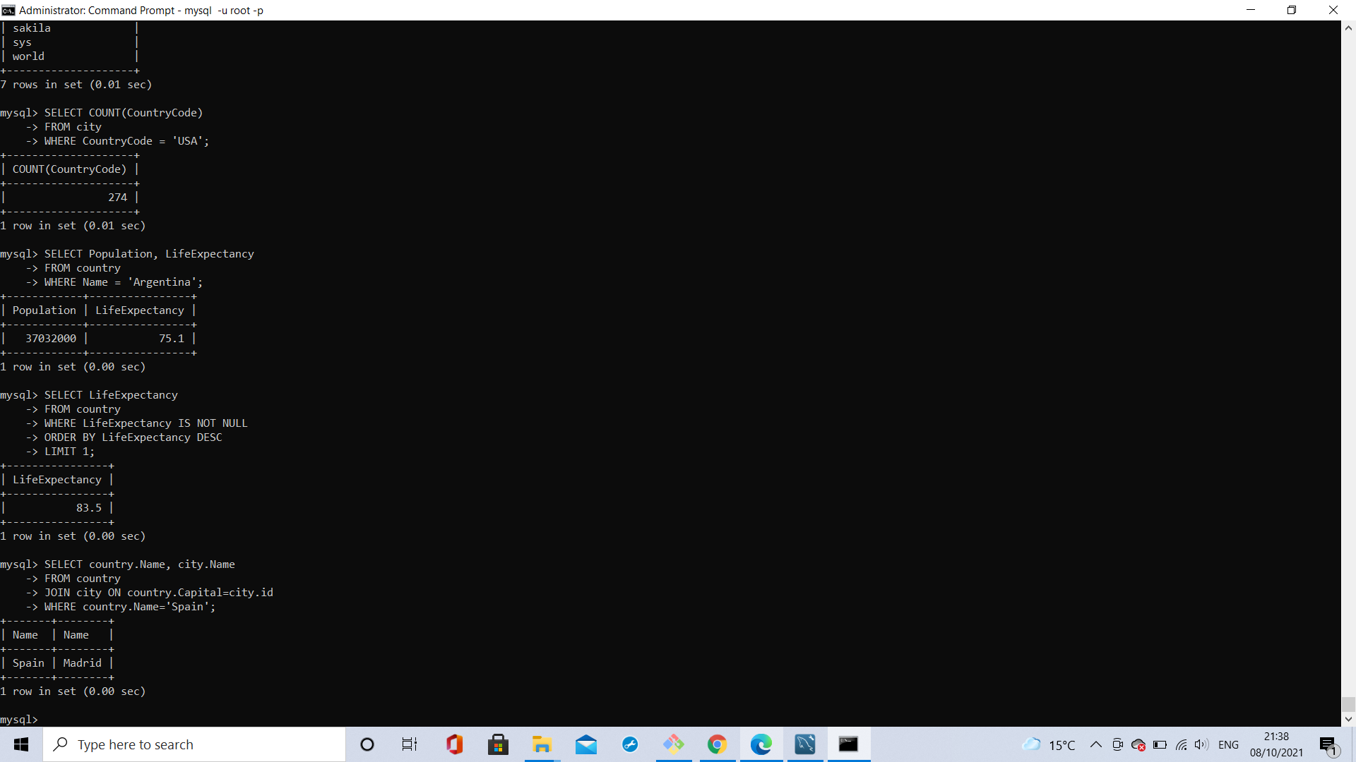

### **2) Find out the population and life expectancy for people in Argentina.**

SELECT Population, LifeExpectancy

FROM country

WHERE Name = 'Argentina';



### **3) Using IS NOT NULL, ORDER BY, and LIMIT, which country has the highest life expectancy?**

SELECT LifeExpectancy

FROM country

WHERE LifeExpectancy IS NOT NULL

ORDER BY LifeExpectancy DESC

LIMIT 1;



### **4) Using JOIN ... ON, find the capital city of Spain.**

SELECT country.Name, city.Name

FROM country

JOIN city ON country.Capital=city.id

WHERE country.Name='Spain';



### **5) Using JOIN ... ON, list all the languages spoken in the Southeast Asia region.**

SELECT countrylanguage.Language

FROM countrylanguage

JOIN country ON country.Code=countrylanguage.CountryCode

WHERE country.Region='Southeast Asia';

### 

### 

### **6) Using a single query, list 25 cities around the world that start with the letter F.**

SELECT Name

FROM city

WHERE Name

LIKE 'F%'

LIMIT 25;

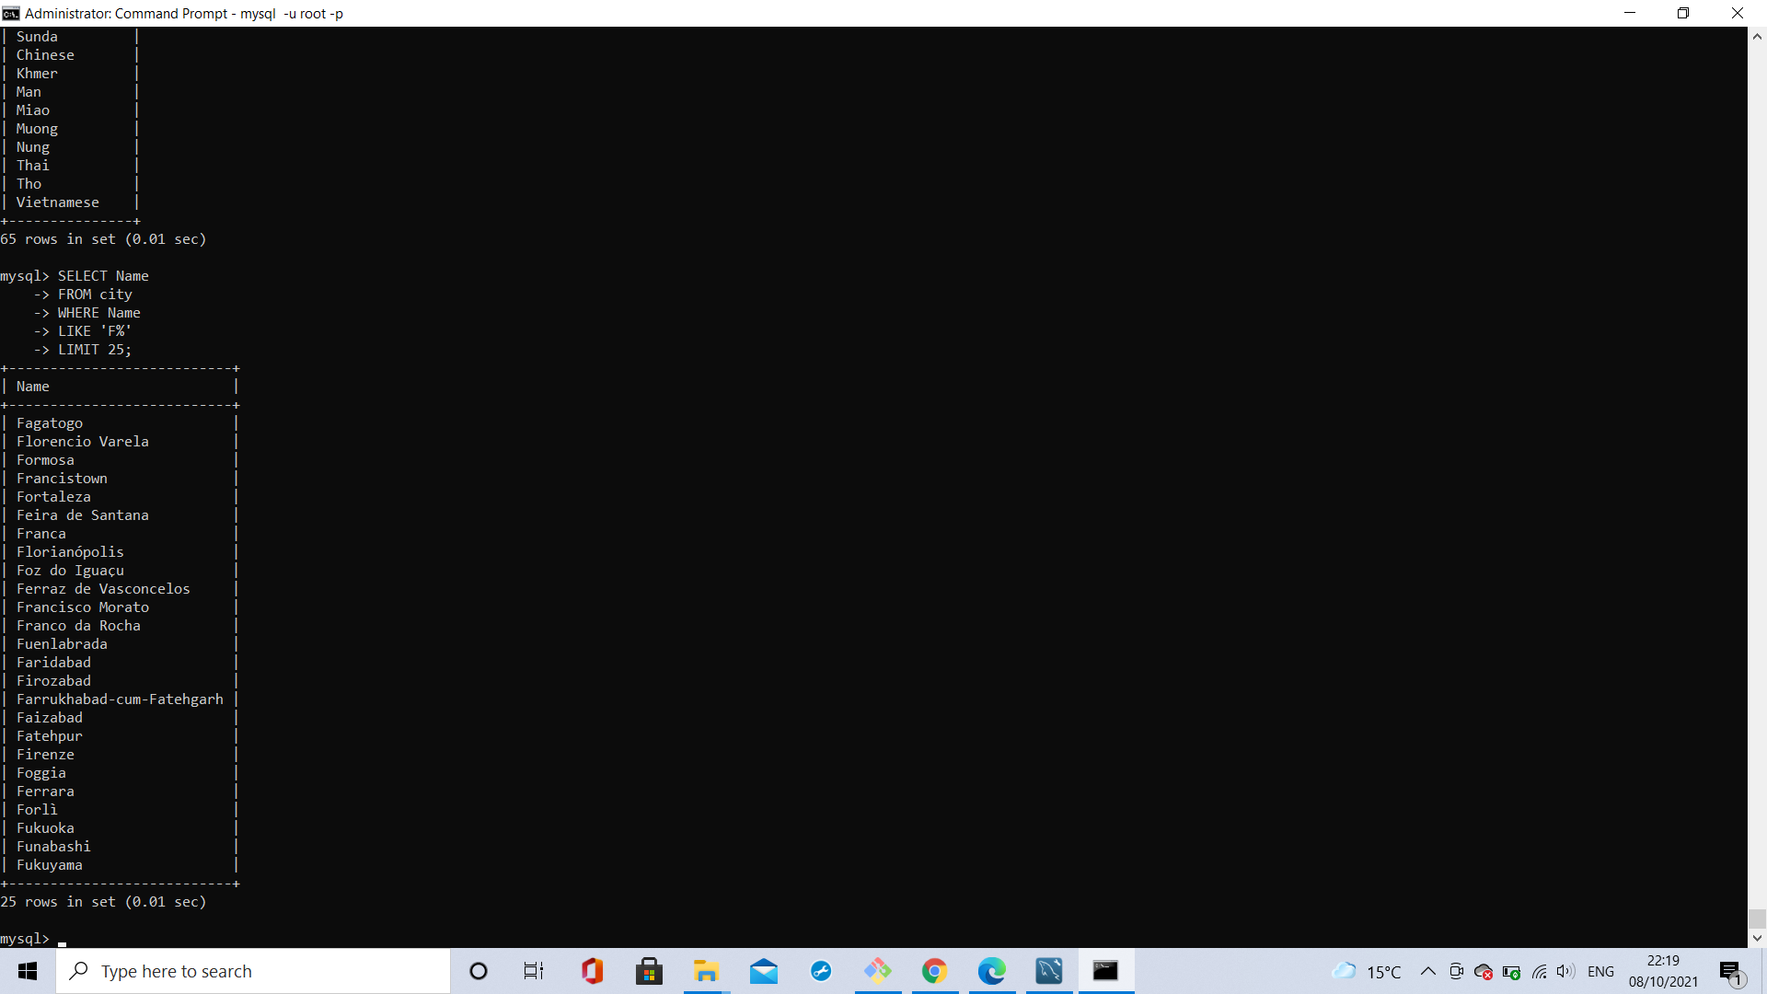

### **7) Using COUNT and JOIN ... ON, get the number of cities in China.**

SELECT COUNT(CountryCode)

FROM city

JOIN country ON country.Code=city.CountryCode

WHERE country.Name='China';

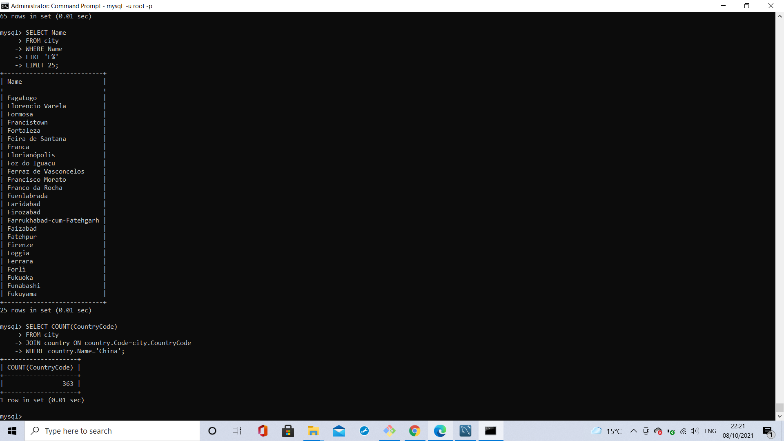

### **8) Using IS NOT NULL, ORDER BY, and LIMIT, which country has the lowest population? Discard non-zero populations.**

SELECT Name, Population

FROM country

WHERE Population IS NOT NULL

ORDER BY Population ASC

LIMIT 1;

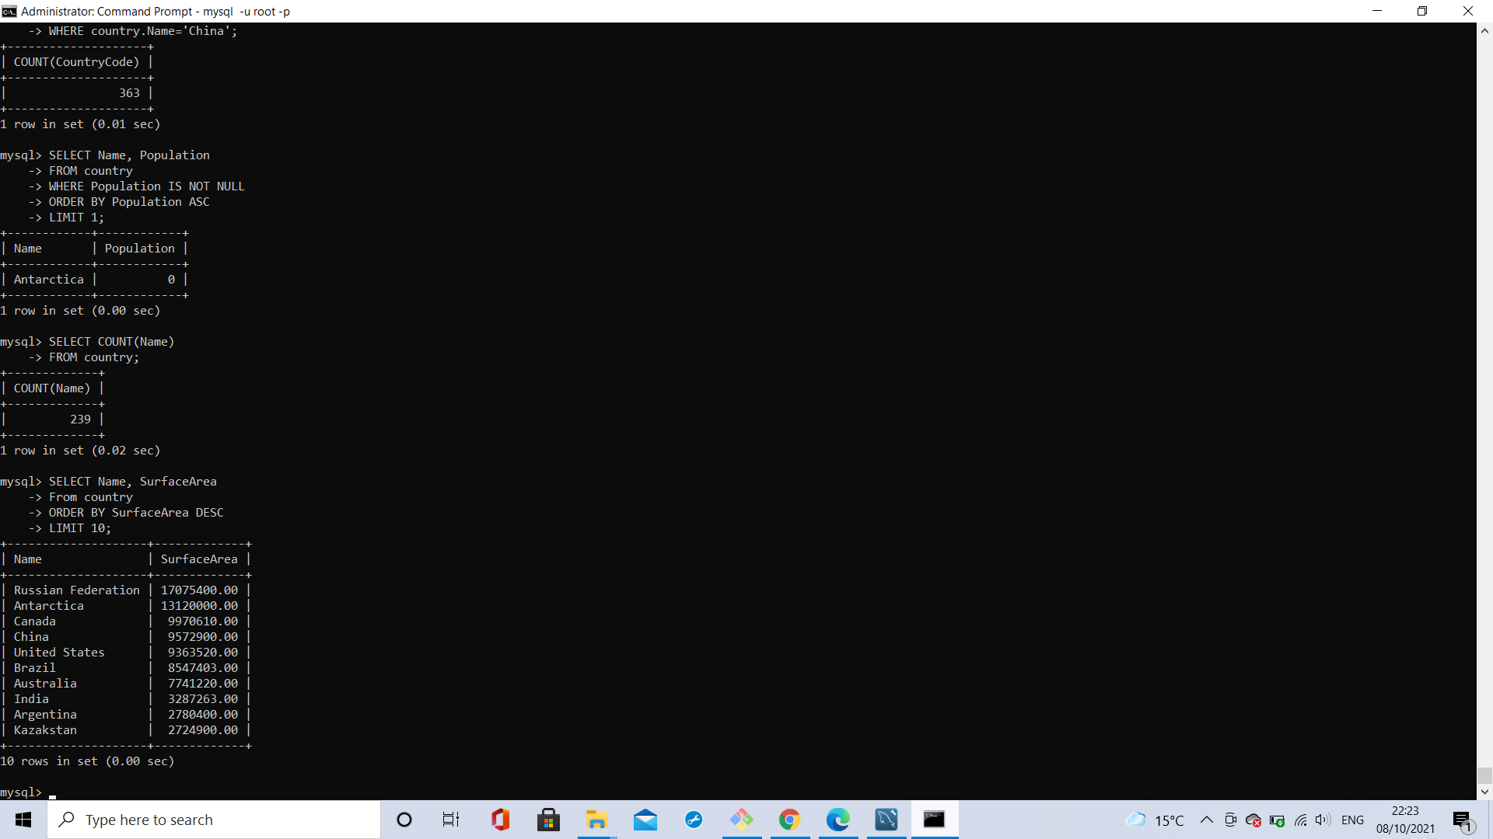

### **9) Using aggregate functions, return the number of countries the database contains.**

SELECT COUNT(Name)

FROM country;



### **10) What are the top ten largest countries by area?**

SELECT Name, SurfaceArea

From country

ORDER BY SurfaceArea DESC

LIMIT 10;



### **11) List the five largest cities by population in Japan.**

SELECT city.Name

FROM city

JOIN country ON city.CountryCode=country.Code

WHERE country.Name='Japan'

ORDER BY city.Population DESC

LIMIT 5;

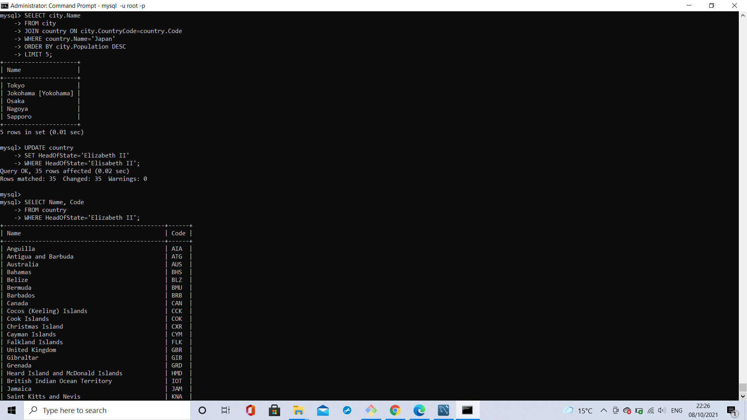

### 

### **12) List the names and country codes of every country with Elizabeth II as its Head of State. You will need to fix the mistake first!**

UPDATE country

SET HeadOfState='Elizabeth II'

WHERE HeadOfState='Elisabeth II';

SELECT Name, Code

FROM country

WHERE HeadOfState='Elizabeth II';



### 

### **13) List the top ten countries with the smallest population-to-area ratio. Discard any countries with a ratio of 0.**

SELECT Name, SurfaceArea, Population, Population / SurfaceArea

FROM country

ORDER BY Population / SurfaceArea ASC, SurfaceArea DESC

LIMIT 10;

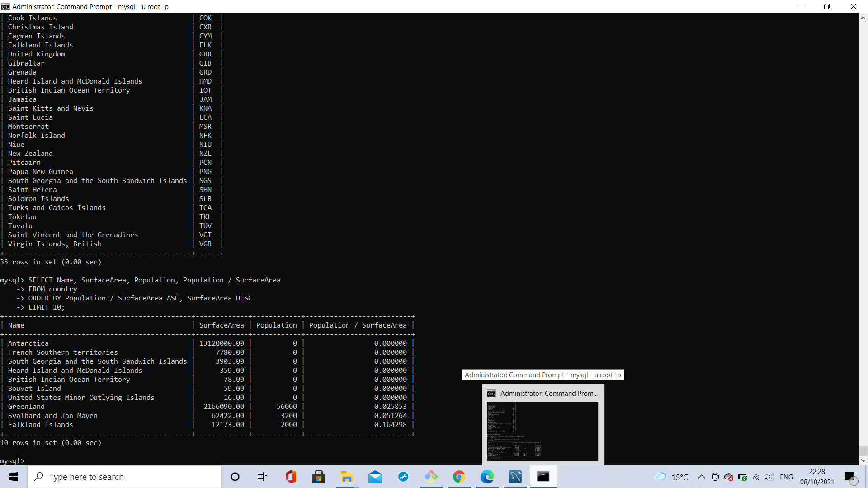

### 

### **14) List every unique world language.**

SELECT DISTINCT Language

FROM countrylanguage;

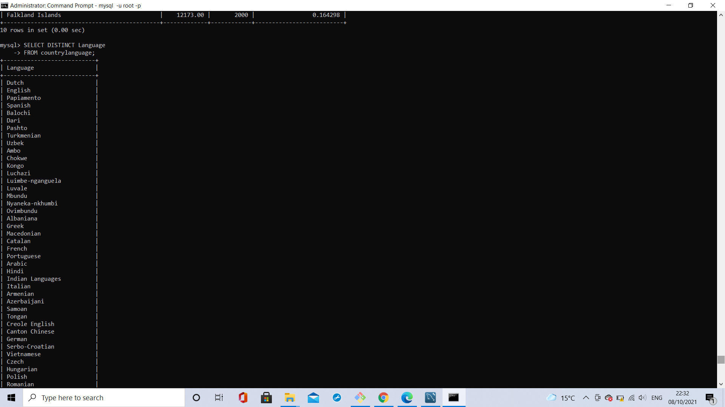

### **15) List the names and GNP of the world's top 10 richest countries.**

SELECT Name, GNP

FROM country

ORDER BY GNP DESC

LIMIT 10;

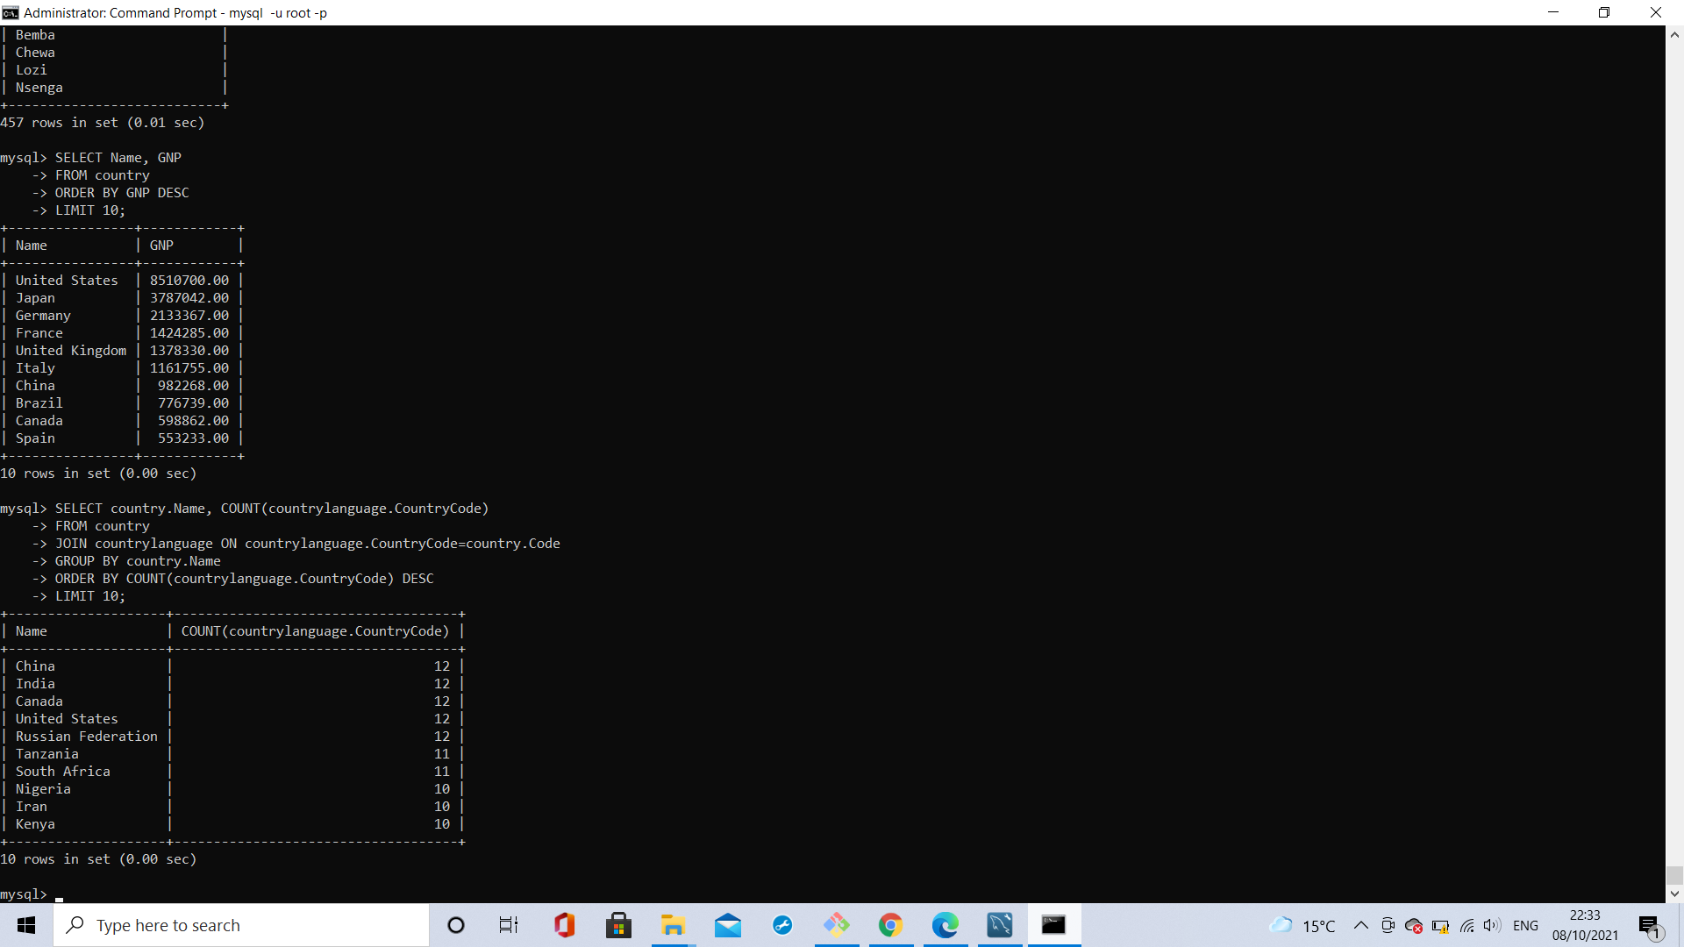

### **16) List the names of, and number of languages spoken by, the top ten most multilingual countries.**

SELECT country.Name, COUNT(countrylanguage.CountryCode)

FROM country

JOIN countrylanguage ON countrylanguage.CountryCode=country.Code

GROUP BY country.Name

ORDER BY COUNT(countrylanguage.CountryCode) DESC

LIMIT 10;



### **17) List every country where over 50% of its population can speak German.**

SELECT country.Name

FROM country

JOIN countrylanguage ON countrylanguage.CountryCode=country.Code

WHERE countrylanguage.Language='German'

AND countrylanguage.Percentage >= 50.00;

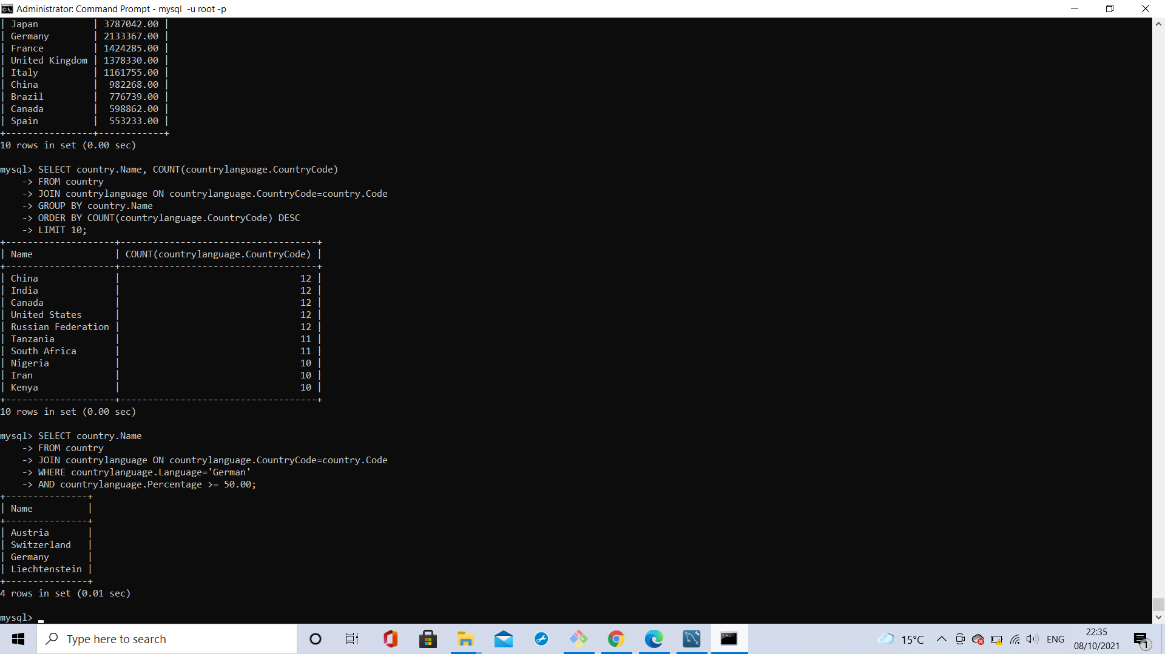

### **18) Which country has the worst life expectancy? Discard zero or null values.**

SELECT Name, LifeExpectancy

FROM country

WHERE LifeExpectancy IS NOT NULL

AND LifeExpectancy > 0

ORDER BY LifeExpectancy ASC

LIMIT 1;

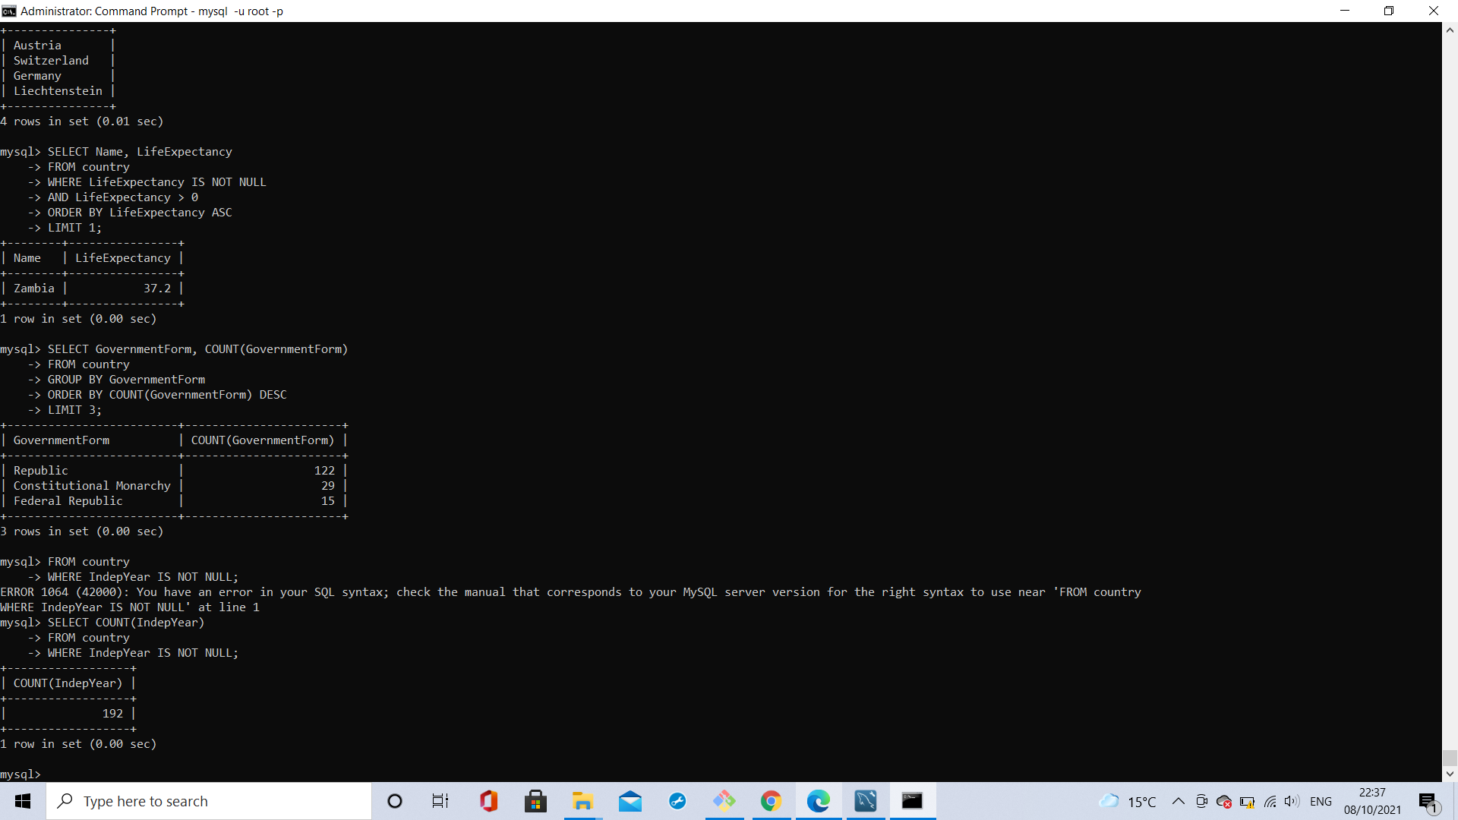

### **19) List the top three most common government forms.**

SELECT GovernmentForm, COUNT(GovernmentForm)

FROM country

GROUP BY GovernmentForm

ORDER BY COUNT(GovernmentForm) DESC

LIMIT 3;



### **20) How many countries have gained independence since records began?**

**SELECT COUNT(IndepYear)**

FROM country

WHERE IndepYear IS NOT NULL;

